MongoDB Compass
Step 0: Download and Install MongoDB Compass
Step 1: Establishing connection with MongoDB Compass
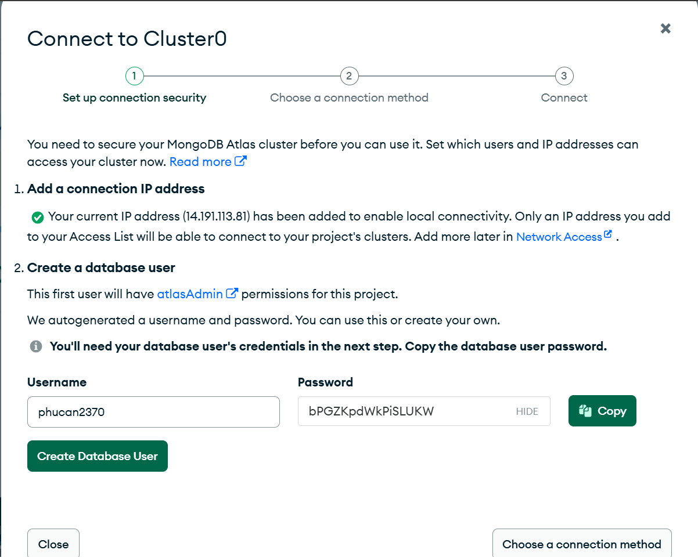

Phucan2370
bPGZKpdWkPiSLUKW

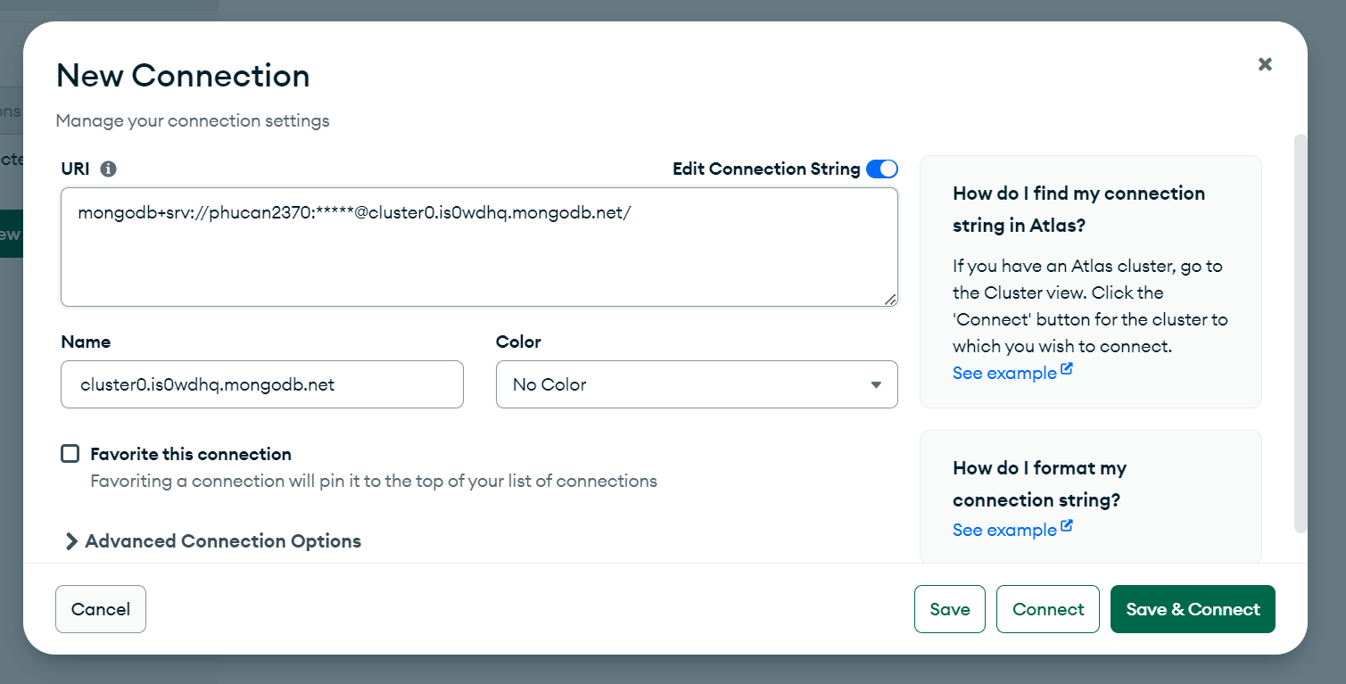
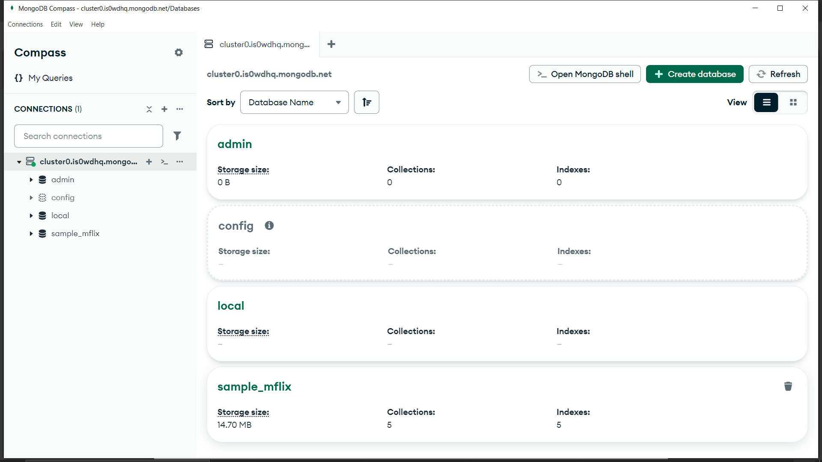

3. Creating and Managing Database using Compass
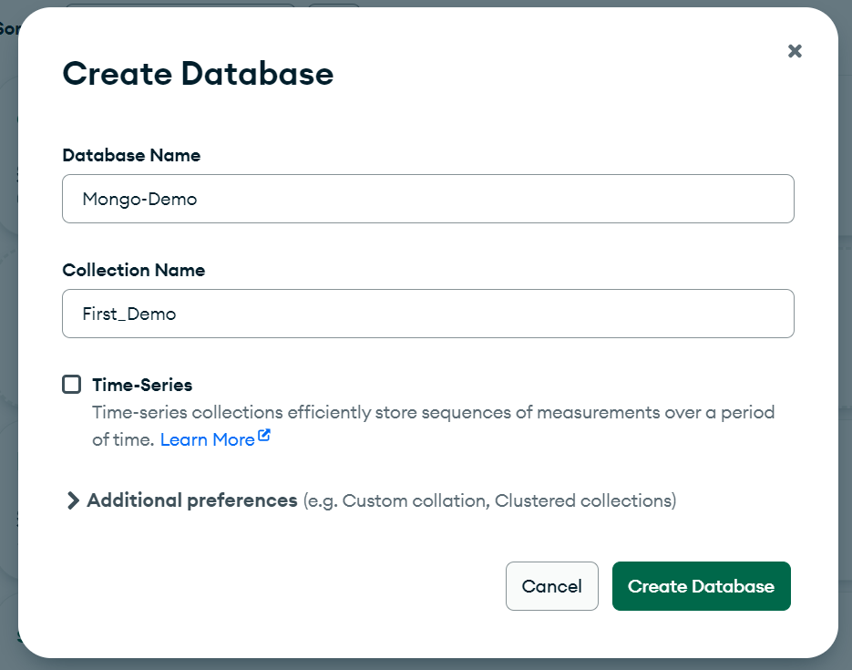
4. Drop a Database in Compass
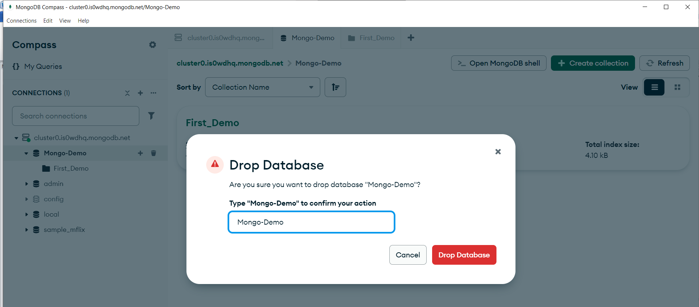
5. Create a Collection in MongoDB Compass
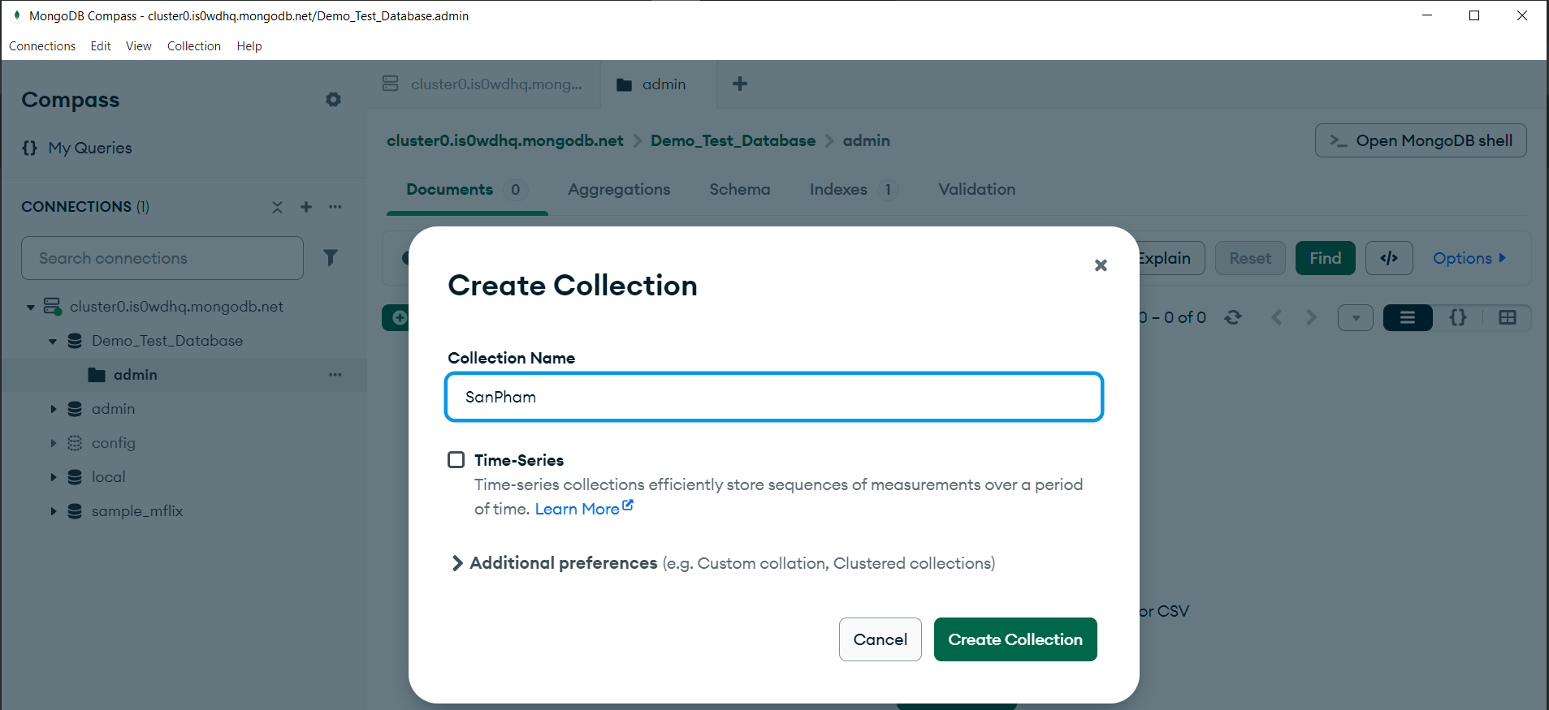

6. Managing Documents in MongoDB Compass
